Suppose you wish to visualise geospatialdata. Briefly describe the capabilities of a Python library that you would recommend and give an example (code and output) using UK data.
-------------------------------

A Python library I would recommend for visualising geospatial data is GeoPandas.

According to the GeoPandas documentation, GeoPandas functions by extending the pandas data types to include new data types which allow for manipulation and visualisation of geographic data specifically. Pandas works primarily with Pandas Series or Dataframes, and GeoPandas builds upon this foundation this by refactoring these data types into two new data types for GeoPandas. These are GeoSeries and GeoDataframes.

With these new data types, GeoPandas uses other packages such as shapely, fiona and matplotlib to both operate on and plot the geographical data. GeoPandas accepts multiple different data file formats which makes the library extremely versatile when considering that different data sources may store their data in a variety of spatial data formats, the most common being GeoJSON, shapefile and gpkg.

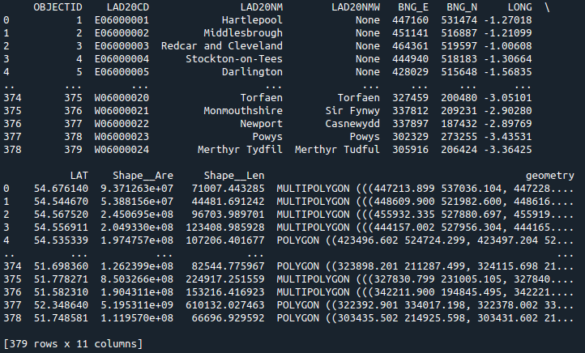
Once these files have been read, they initially appear to resemble a general Pandas dataframe however, these file formats will always include geographical values within the dataframe

Specific columns in my dataset that can demonstrate this are the “LONG” and “LAT” columns, and more notably, the “geometry” column. In the image above, it can be seen that the values in that column are unique, and would not look as common in a standard Pandas dataframe. The geometry values are what GeoPandas uses for spatial operations and analysis.

In my example, I used two datasets. The first dataset consists of Local Authority Districts within the United Kingdom.

